User Manual

of

(Version 2023.1)

(A free and open-source software)

CSAY OBSTACLE HEIGHT CALCULATION

Er. AJAY YADAV

2023

Based

on

ICAO ANNEX-14, VOL-I, OLS

Table of Content

LIST OF FIGURES 1

CHAPTER 1 DEFINITION 2

1.1 Definitions as per ICAO Annex 14 2

1.1.1 Aerodrome 2

1.1.2 Balked Landing 2

1.1.3 Aerodrome Reference point 2

1.1.4 Clearway 2

1.1.5 Displaced Threshold 2

1.1.6 Obstacle 2

1.1.7 Obstacle Free Zone (OFZ) 3

1.1.8 Obstacle Limitation Surface (OLS) 3

1.1.9 Runway 3

1.1.10 Runway strips 3

1.1.11 Threshold 3

CHAPTER 2 OBSTACLE LIMITATION SURFACE 4

2.1 Types of Obstacle Limitation Surfaces 4

2.2 OLS requirement 4

2.3 Details of each OLS 5

2.3.1 Conical Surface 5

2.3.2 Inner Horizontal Surface 6

2.3.3 Inner Approach Surface 7

2.3.4 Approach Surface 8

2.3.5 Transitional Surface 9

2.3.6 Inner Transitional Surface 9

2.3.7 Balked Landing Surface 11

2.3.8 Take Off Climb Surface 12

2.3.9 Outer Horizontal Surface 13

CHAPTER 3 INTRODUCTION TO SOFTWARE 14

3.1 Overview of Software 14

3.2 Functions of Software 14

3.3 Limitation of Software 14

3.4 Layout of Software 14

3.5 Input Text files (“*.txt”) and folder 15

3.5.1 Content of TextBox Folder 15

3.5.2 Airport code folder content 16

3.5.3 Others Texfile input format 18

3.6 Content of Tab 19

3.6.1 Load All Record 19

3.6.2 RWY COORD and Eq 19

3.6.3 RWY to Obstacle Distance Calculate 20

3.6.4 General 21

3.6.5 Letters and others 22

3.6.6 English Letter Preview 22

3.6.7 Calculation Detail 23

3.6.8 RWY Classification and other 23

3.6.9 RL of RWY CL 24

3.6.10 Coord Trans 24

3.6.11 Menu 25

3.6.12 Filter 26

3.7 Nomenclature of Runway corners 27

3.8 Output 27

3.8.1 Report 27

3.8.2 Letter in Nepali 29

3.8.3 Tippani in Nepali 30

3.8.4 Letter in English 31

3.9 Steps to calculate Obstacle Height with Auot-Process 32

# LIST OF FIGURES

Figure 1. Rwy, Strip and other detail 3

Figure 2. Conical Surface 5

Figure 3. Inner Horizontal Surface 6

Figure 4. Inner Approach Surface 7

Figure 5. Approach Surface 8

Figure 6. Transitional Surface 9

Figure 7. Inner Transitional Surface (AB Side) 10

Figure 8. Inner Transitional Surface (CD Side) 10

Figure 9. Balked Landing Surface 11

Figure 10. Take off Climb Surface 12

Figure 11. Outer Horizontal Surface 13

Figure 12. Input folder and its content 15

Figure 13. TextBox Folder Content 15

Figure 14. Airport Code (e.g., VNBW) Folder Content 16

Figure 15. Other textfile content format 18

Figure 16. Load all Records Tab 19

Figure 17. RWY COORD and Eq Tab 19

Figure 18. RWY to Obstacle Distance Calculate Tab 20

Figure 19. DMS to DD Converter 20

Figure 20. General Tab 21

Figure 21. Letters and Others Tab 22

Figure 22. English Letter Preview Tab 22

Figure 23. Calculation Detail 23

Figure 24. RWY Classification and other Tab 23

Figure 25. RL of RWY CL tab 24

Figure 26. Coord Trans tab 24

Figure 27. Menu 25

Figure 28. About 26

Figure 29. Filter 26

Figure 30. Runway corner nomenclature 27

Figure 31. Software Executable file Location 32

# DEFINITION

## Definitions as per ICAO Annex 14

### Aerodrome

A defined area on land or water (including any buildings, installations and equipment) intended to be used either wholly or in part for the arrival, departure and surface movement of aircraft.

### Balked Landing

A landing manoeuvre that is unexpectedly discontinued at any point below the obstacle clearance altitude/height (OCA/H).

### Aerodrome Reference point

The designated geographical location of an aerodrome

### Clearway

A defined rectangular area on the ground or water under the control of the appropriate authority, selected or prepared as a suitable area over which an aeroplane may make a portion of its initial climb to a specified height.

### Displaced Threshold

A threshold not located at the extremity of a runway

### Obstacle

All fixed (whether temporary or permanent) and mobile objects, or parts thereof, that:

a) are located on an area intended for the surface movement of aircraft; or

b) extend above a defined surface intended to protect aircraft in flight; or

c) stand outside those defined surfaces and that have been assessed as being a hazard to air navigation.

### Obstacle Free Zone (OFZ)

The airspace above the inner approach surface, inner transitional surfaces, and balked landing surface and that portion of the strip bounded by these surfaces, which is not penetrated by any fixed obstacle other than a low-mass and frangibly mounted one required for air navigation purposes.

### Obstacle Limitation Surface (OLS)

It defines the limit to which objects may project into the airspace

### Runway

A defined rectangular area on a land aerodrome prepared for the landing and take-off of aircraft.

### Runway strips

A defined area including the runway and stopway, if provided, intended:

a) to reduce the risk of damage to aircraft running off a runway; and

b) to protect aircraft flying over it during take-off or landing operations.

### Threshold

The beginning of that portion of the runway usable for landing.

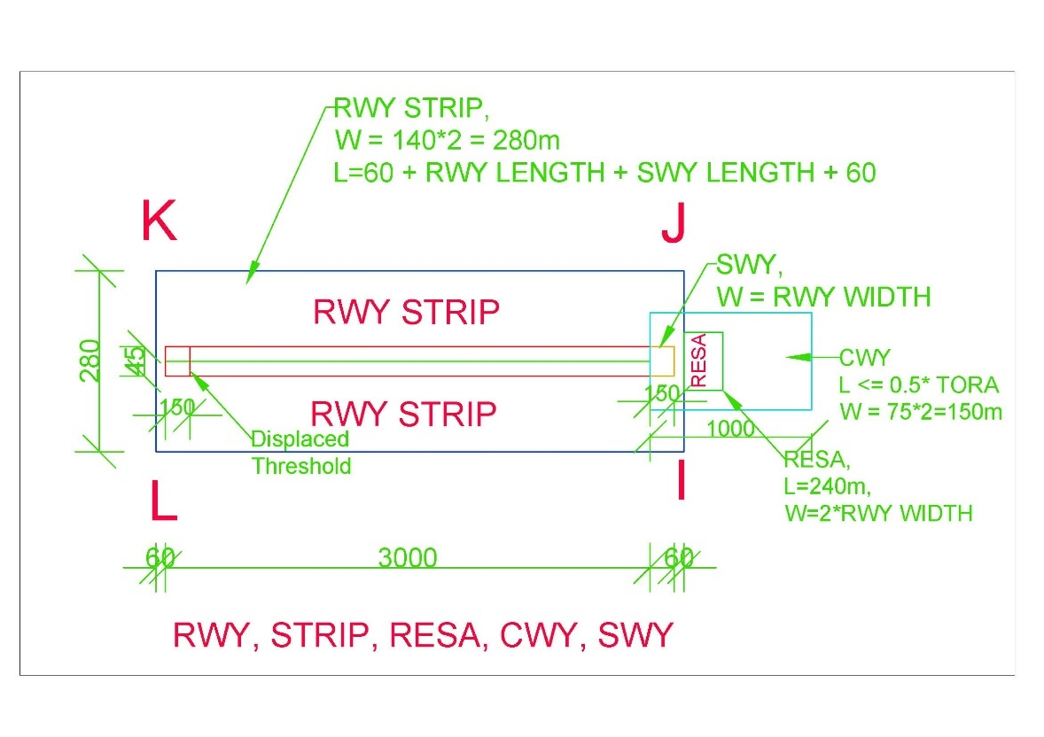

Figure 1. Rwy, Strip and other detail

# OBSTACLE LIMITATION SURFACE

## Types of Obstacle Limitation Surfaces

1. CONICAL SURFACE
2. INNER HORIZONTAL SURFACE
3. INNER APPROACH SURFACE
4. APPROACH SURFACE
5. TRANSITIONAL SURFACE
6. INNER TRANSITIONAL SURFACE
7. BALKED LANDING SURFACE
8. TAKEOFF CLIMB SURFACE
9. OUTER HORIZONTAL SURFACE

## OLS requirement

|  |  |  |
| --- | --- | --- |
| Runway Category | Runway Sub-Category | Obstacle Limitation surface |
| Non-Instrument Runway |  | 1. Conical surface 2. Inner Horizontal 3. Approach surface 4. Transitional surface |
| Instrument Runway | Non-Precision Approach Runway | 1. Conical surface 2. Inner Horizontal 3. Approach surface 4. Transitional surface |
| Precision Approach Runway Category I | Mandatory Surfaces (Shall be)   1. Conical surface 2. Inner Horizontal 3. Approach surface 4. Transitional surface   *Optional Surfaces (Should be)*   1. *Inner Approach surface* 2. *Inner Transitional surface* 3. *Balked landing surface* |
| Precision Approach Runway Category II or III | 1. Conical surface 2. Inner Horizontal 3. Approach surface 4. Transitional surface 5. Inner Approach surface 6. Inner Transitional surface 7. Balked landing surface |

* Note – 1: Take off climb surface shall be established for all runways meant of Take off climb.

## Details of each OLS

In this document, calculations and drawings shall be based on “**PRECISION APPROACH RUNWAY CAT II OR III**” based on Table 4-1 Dimensions and slopes of obstacle limitation surfaces — Approach runways of ICAO ANNEX – 14, Vol – I, 9th Edition.

### Conical Surface

|  |  |
| --- | --- |
| Surfaces | Dimension |
| CONICAL |  |
| Slope_% | 5 |
| Height_m | 100 |

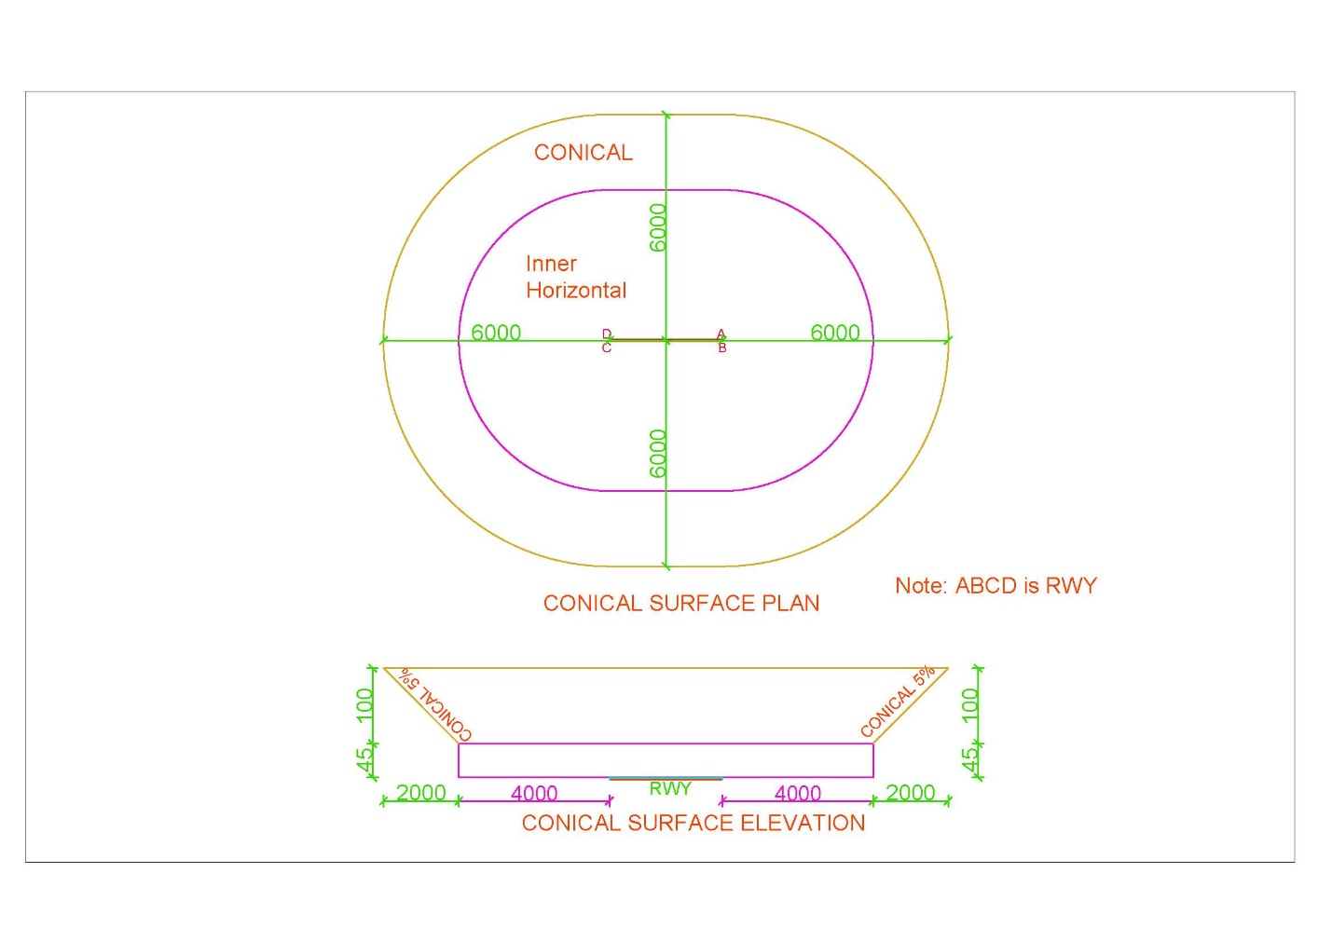

Figure 2. Conical Surface

### Inner Horizontal Surface

|  |  |
| --- | --- |
| Surfaces | Dimension |
| INNER_HORIZONTAL |  |
| Height_m | 45 |
| Radius_m | 4000 |

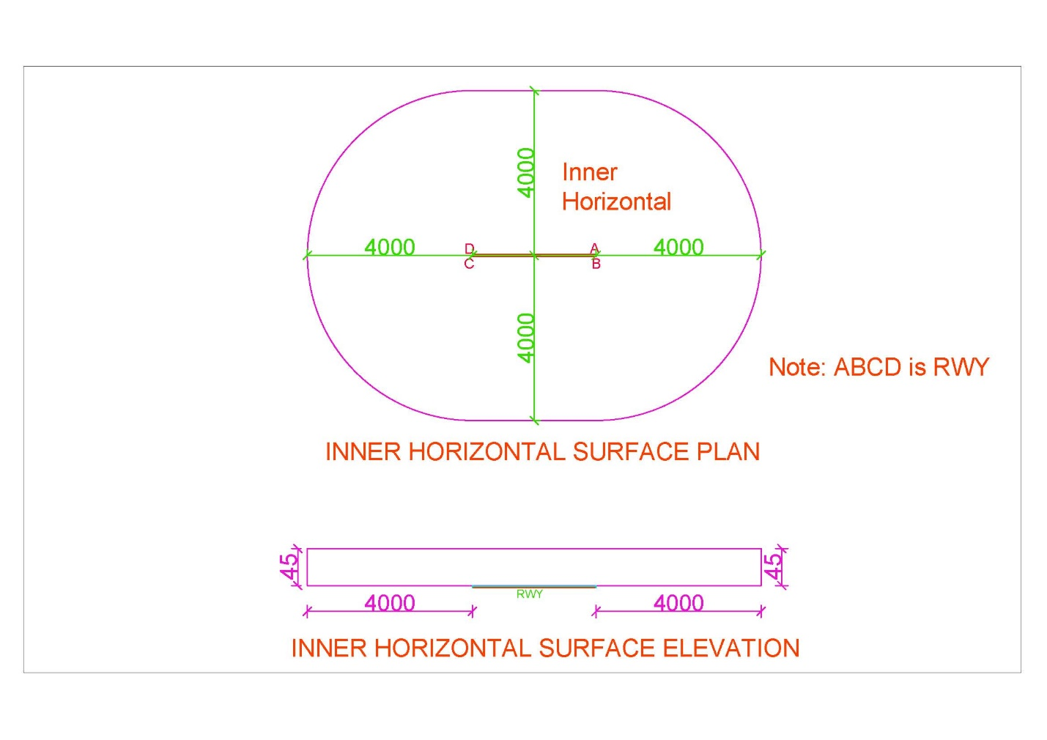

Figure 3. Inner Horizontal Surface

### Inner Approach Surface

|  |  |
| --- | --- |
| Surfaces | Dimension |
| INNER_APPROACH |  |
| Width_m | 120 |
| Distance_from_threshold_m | 60 |
| Length_m | 900 |
| Slope_% | 2 |

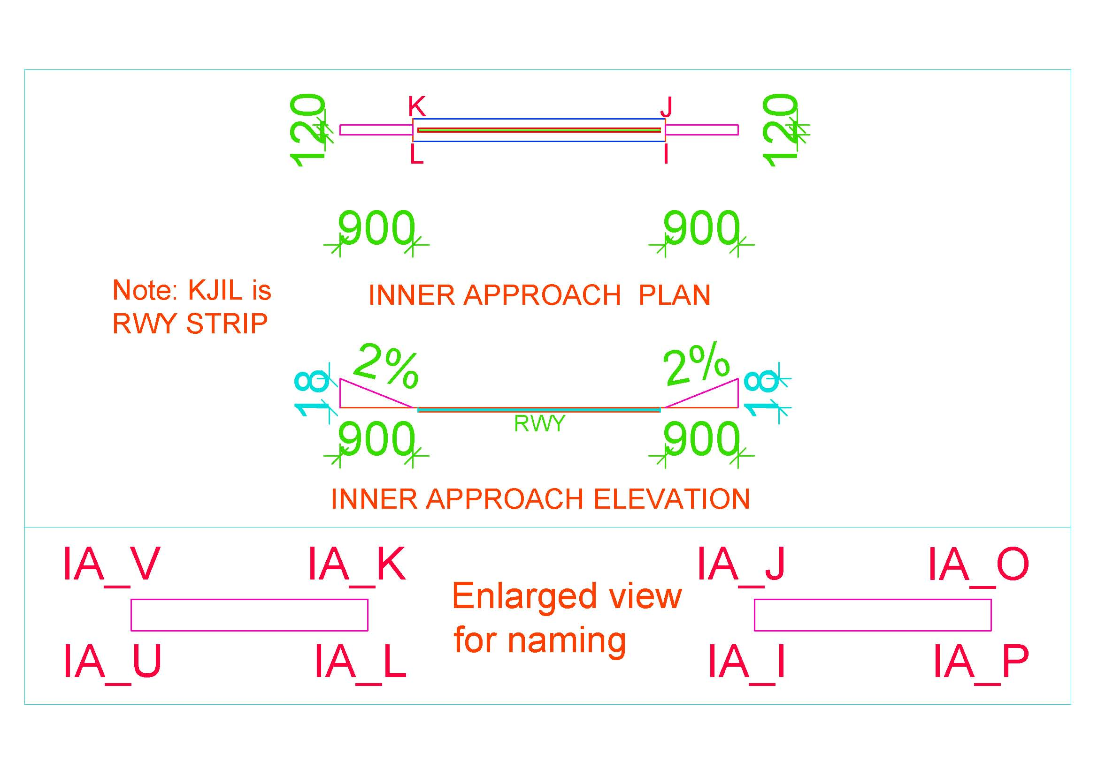

Figure 4. Inner Approach Surface

### Approach Surface

|  |  |  |  |
| --- | --- | --- | --- |
| Surfaces | Dimension | Surfaces | Dimension |
| Length_of_inner_edge_m | 280 | Second_Section |  |
| Distance_from_threshold_m | 60 | Length_m | 3600 |
| Divergence_% | 15 | Slope_% | 2.5 |
| First_Section |  | Horizontal_Section |  |
| Length_m | 3000 | Length_m | 8400 |
| Slope_% | 2 |  |  |

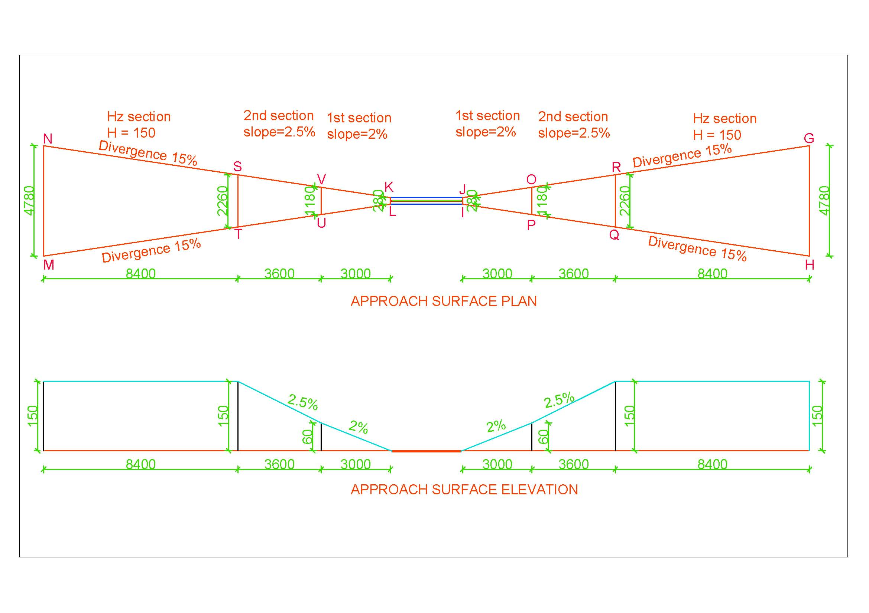

Figure 5. Approach Surface

### Transitional Surface

|  |  |
| --- | --- |
| Surfaces | Dimension |
| INNER_TRANSITIONAL |  |
| Slope_% | 14.3 |

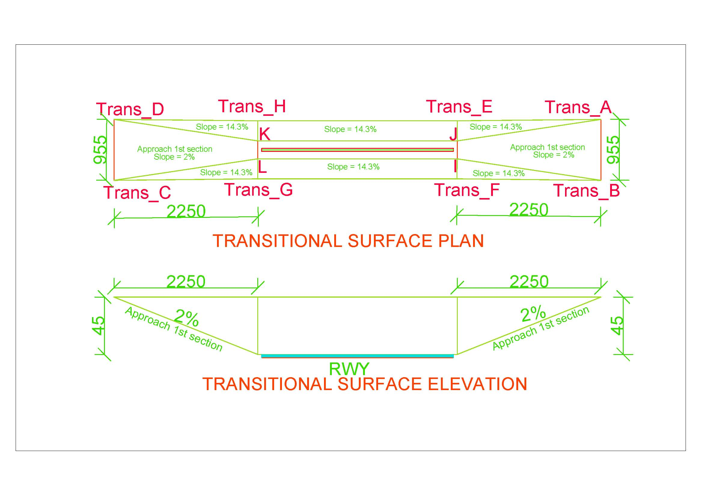

Figure 6. Transitional Surface

### Inner Transitional Surface

|  |  |
| --- | --- |
| Surfaces | Dimension |
| TRANSITIONAL |  |
| Slope_% | 33.3 |

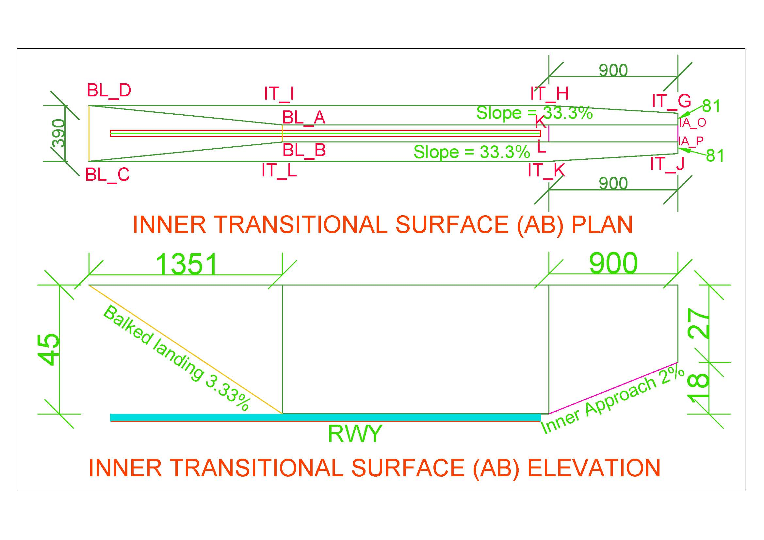

Figure 7. Inner Transitional Surface (AB Side)

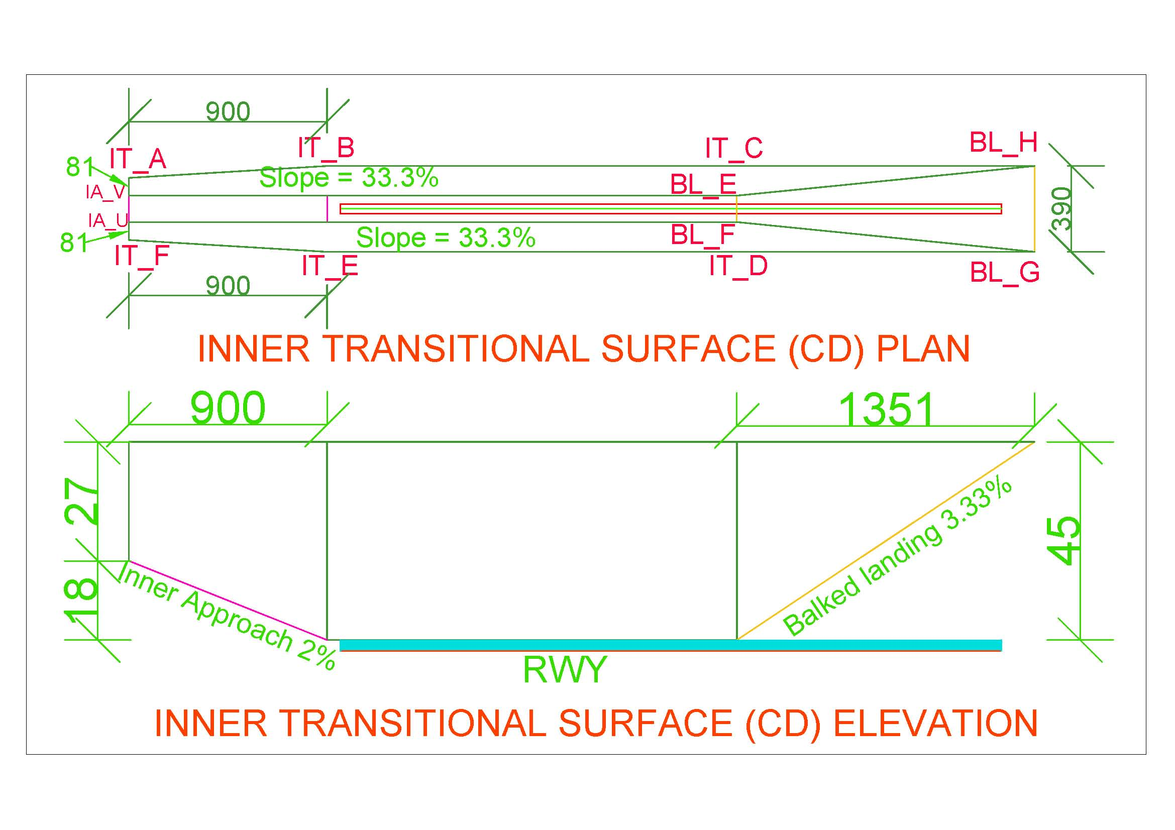

Figure 8. Inner Transitional Surface (CD Side)

### Balked Landing Surface

|  |  |
| --- | --- |
| Surfaces | Dimension |
| BALKED_LANDING |  |
| Length_of_inner_edge_m | 120 |
| Distance_from_threshold_m | 1800 |
| Divergence_% | 10 |
| Slope_% | 3.33 |

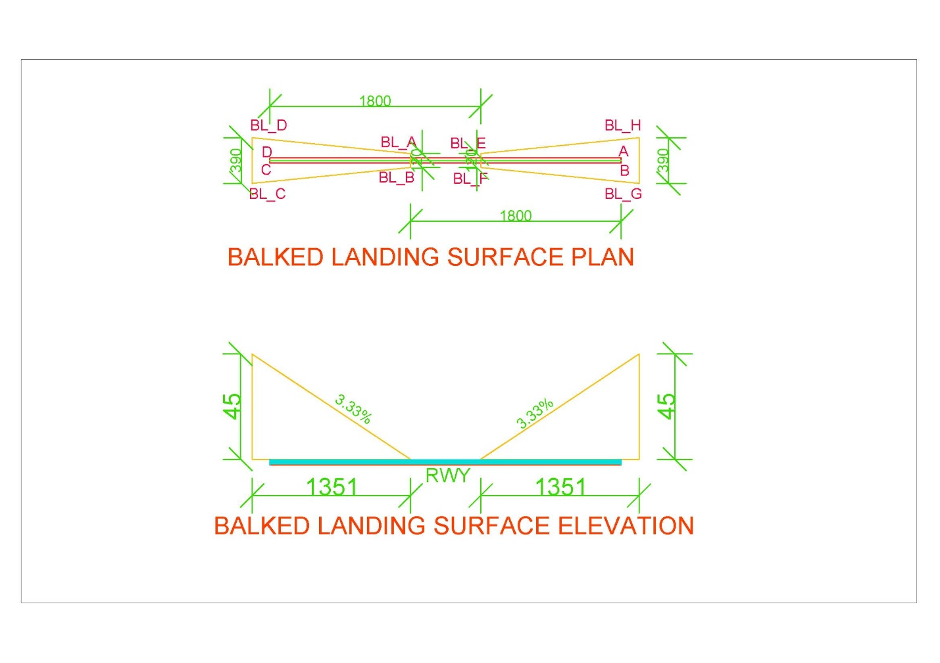

Figure 9. Balked Landing Surface

* *Note:* 
  + *If threshold is displaced by distance ‘d’, Balked landing surface will also be displaced by distance ‘d’ in the direction of displaced threshold.*
  + *In* Figure 14 *“VNBW.txt”, AB_Threshold_displaced_By and CD_Threshold_displaced_By shall be given value d1 and d2 respectively if Threshold AB is displaced by d1 and CD is displaced by d2.*
  + *If thresholds aren’t displaced, value will be zero*

### Take Off Climb Surface

|  |  |
| --- | --- |
| Surfaces | Dimension |
| TAKE_OF_CLIMB_SURFACE |  |
| Length_of_inner_edge_m | 180 |
| Distance_from_RWY_End_m | 60 |
| Divergence_% | 12.5 |
| Final_Width_m | 1800 |
| Length_m | 15000 |
| Slope_% | 2 |

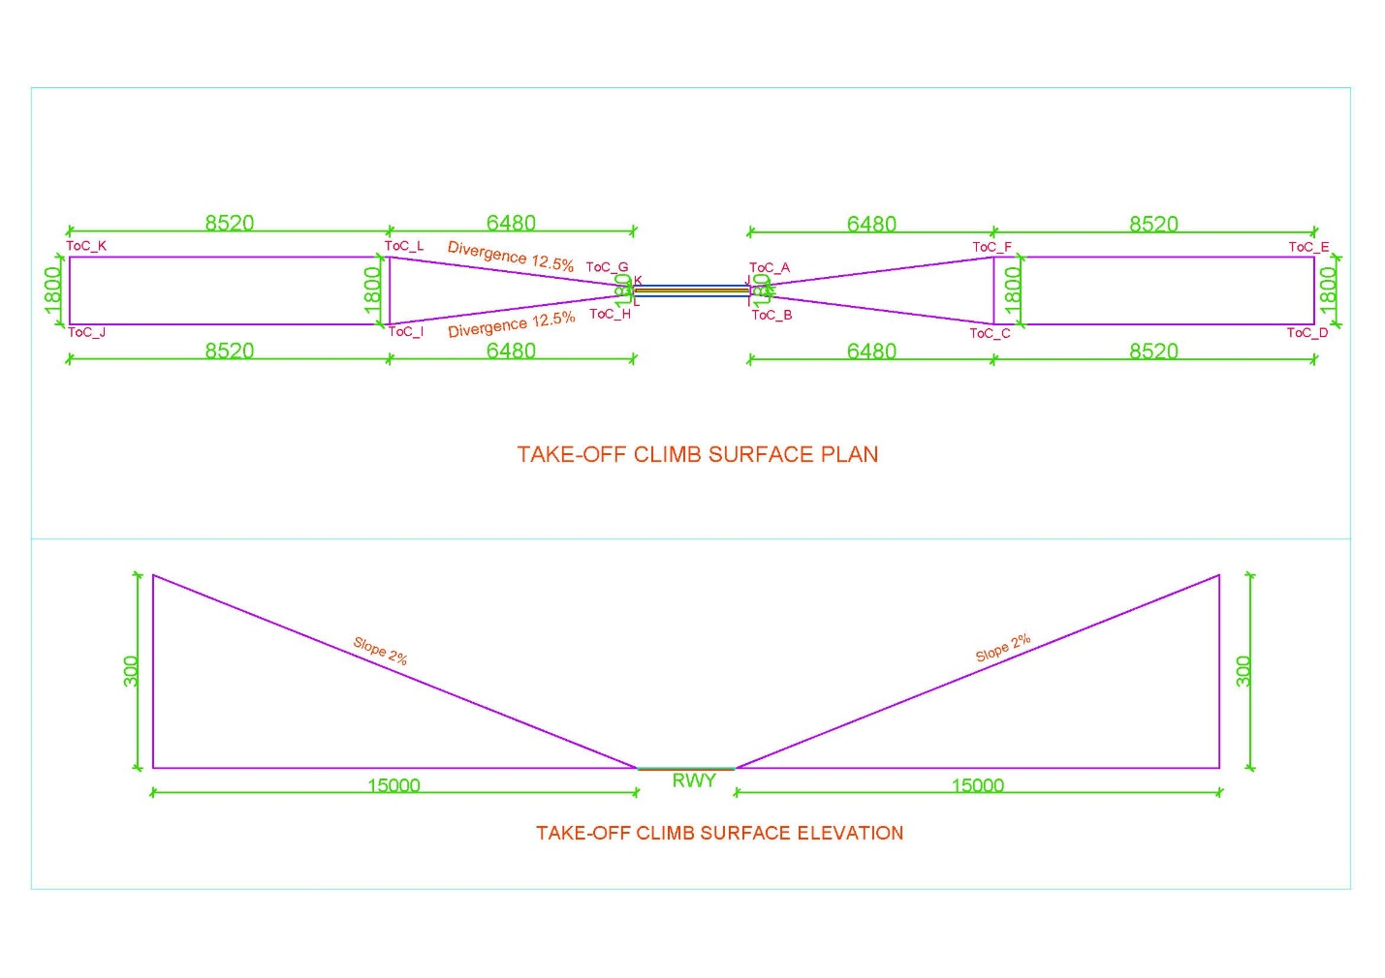

Figure 10. Take off Climb Surface

* *Note:* 
  + *Take-Off Climb Surface starts from 60m end of runway (i.e. RWY strip) or end of clearway, whichever is greater.*
  + *For example, as in* Figure 1*,*
    - *Distance of strip from RWY end (d1) = SWY + strip end = 150+60=210m*
    - *Distance of CWY from RWY end (d2) = 1000 m*
    - *Distance beyond strip end of CWY = 1000-210=790 m = d*
    - *This value i.e., ‘d’ is to be placed for respective end of runway in AB_CLWY_beyond_strip and CD_CLWY_beyond_strip as in* ***Error! Reference source not found.***Figure 14*.*

### Outer Horizontal Surface

|  |  |
| --- | --- |
| Surfaces | Dimension |
| Center at | ARP |
| Radius_m | 15000 |

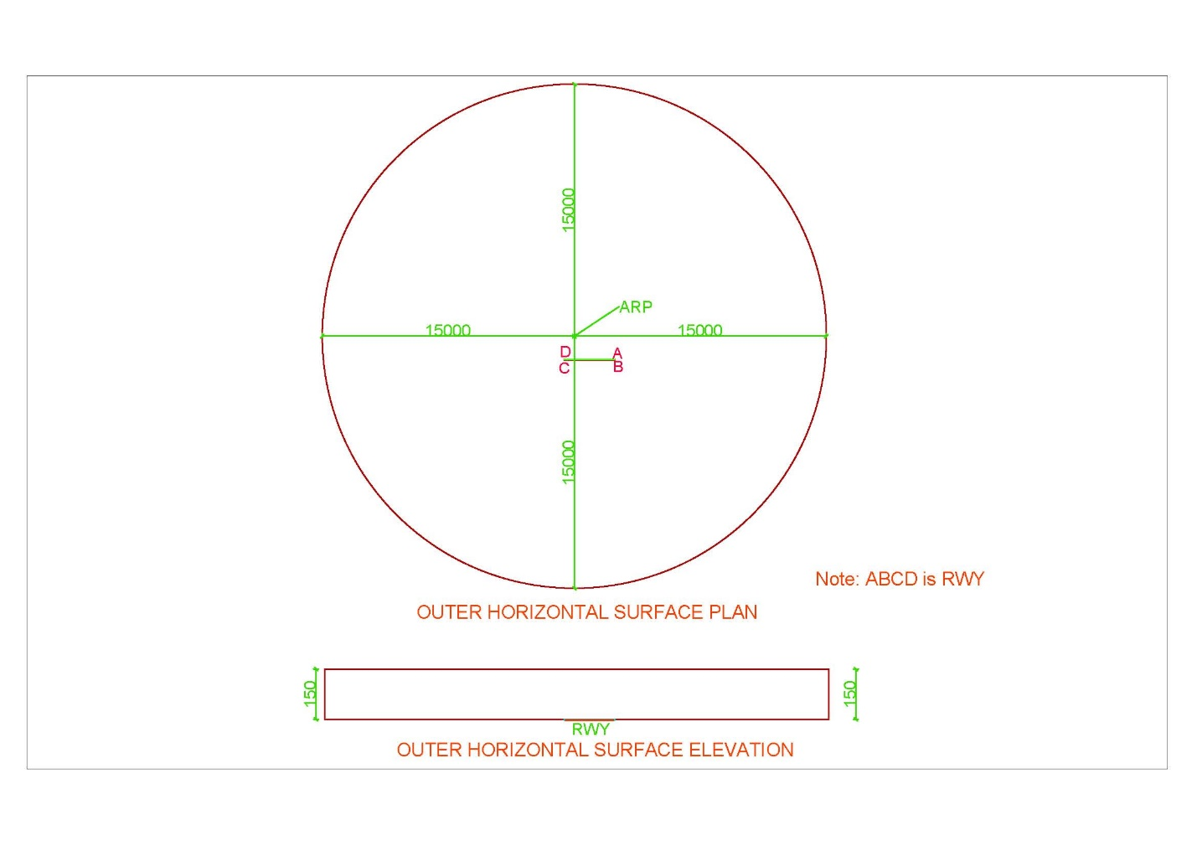

Figure 11. Outer Horizontal Surface

# INTRODUCTION TO SOFTWARE

## Overview of Software

|  |  |
| --- | --- |
| Name of the Software | **CSAY Obstacle Height Calculation** |
| Version | 2023.1 |
| Type | Free and Open source |
| Operating System | Windows 10 (preferable) or higher |
| Display resolution of Monitor screen (Recommended) | 1366 x 768 |
| Setup | No installation required |
| Link to download | <https://github.com/ajayyadavay/CSAYObstacleHeightCalculation> |
| Created/Developed/Programmed by | Er. Ajay Yadav |
| E-mail: | [Civil.ajayyadav@gmail.com](mailto:Civil.ajayyadav@gmail.com) |

## Functions of Software

1. Finds the height of the obstacle
2. Generates OLS for any runway orientation of any country with correct input of Projection system of coordinate
3. Creates pdf of the report
4. Draws map of Obstacle Limitation surface and plotted point showing distance between runway and obstacle location
5. Creates tippani in Nepali and Letter in Nepali as well as English
6. Exports the route between runway and obstacle and their points to KML file
7. Allows user to Perform database operations: ADD, MODIFY, DELETE, DISPLAY, FILTER
8. Exports the saved/added data to excel
9. Allows user to Auto process which will generate report, tippani, letter, KML and Map saved in a folder
10. Allows user to enter decimal degrees (DD) of location of obstacle and also assists in converting from Degree, Minute and Second (DMS) format to DD.
11. Allows user to draw all the obstacle limitation surfaces or only selected surfaces
12. Allows user to extract coordinate (latitude and longitude) from map on mouse click

## Limitation of Software

1. This software can be used for airport having only one Runway and not for airport having the parallel or intersecting runways or more than one Runways.

## Layout of Software

1. There are Ten Tabs
2. All the Text boxes labelled with black foreground is input and others are either calculated textboxes or loaded from the ‘*.txt’ files
3. For Auto process, input all required value and click on menu Processing>Auto Process button
4. Textboxes with orange colored label in “General” tab are compulsory input fields
5. All the Combo Boxes have their values loaded from “*.txt” files
6. Map is drawn in “RWY to obstacle distance calculation” tab
7. At top, there is Menu (File, Database and Processing)

## Input Text files (“*.txt”) and folder

All the text files contain data as per the name of the text files.

*Note: The user is allowed to only edit the content of text files strictly adhering to the format and user cannot rename or delete the text files or change the location of the text files.*

Figure 12 shows folders and its content. The user can edit content as per their requirement.

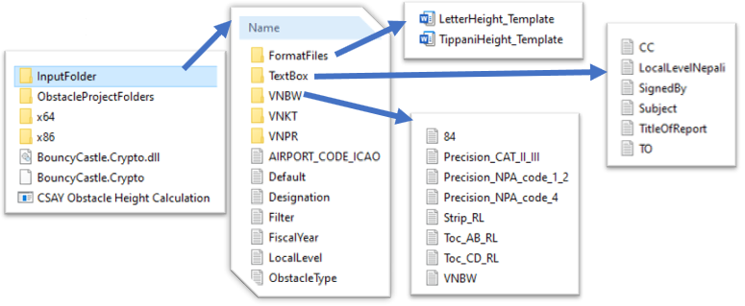

Figure 12. Input folder and its content

### Content of TextBox Folder

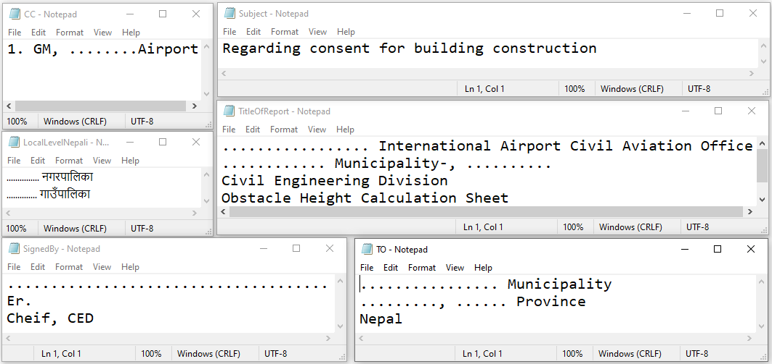

Figure 13. TextBox Folder Content

1. CC.txt 🡪 It contains the name to whom English letter is be sent as CC
2. Subject.txt 🡪 contains subject of English letter
3. LocalLevelNepali.txt 🡪 contains local level name in Nepali/Devanagari and it should be in the same order as that of English local level name as shown in Figure 15.
4. TitleOfReport.txt 🡪 contains title of the report generated
5. SignedBy.txt 🡪 contains name and designation of the one who signs the English letter
6. TO.txt 🡪 contains detail to whom the letter is to be sent

### Airport code folder content

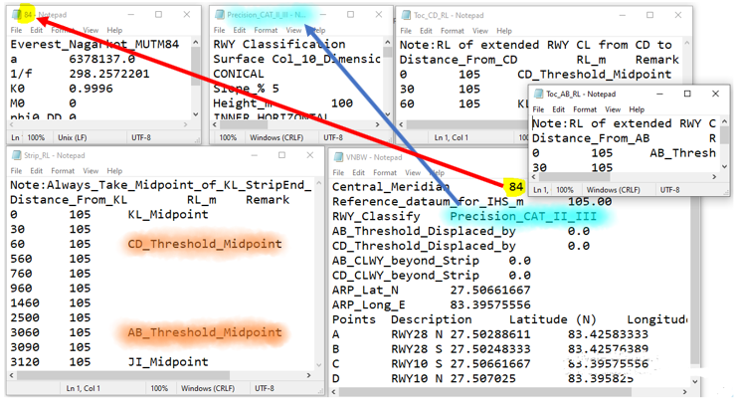

Figure 14. Airport Code (e.g., VNBW) Folder Content

1. “84.txt”
   1. contains parameter of ellipsoid used in 2D projection i.e., to convert latitude and longitude to Easting and Northing and vice-versa.
   2. Instead of “84.txt”, you can rename or create a new file with different longitude, e.g., “87.txt” but “87” should be specified in “VNBW.txt” as value of Central_Meridian.
2. “Precision_CAT_II_III.txt”
   1. contains data of any one column of OLS table of ICAO ANNEX-14, VOL I, chapter 4, which specified dimension of OLS.
   2. Also “Precision_CAT_II_III” should be specified in “VNBW.txt” as value of “RWY_Classify”.
   3. Different filename can be used but should be specified in “VMBW.txt”
3. ToC_CD_RL.txt
   1. This text file contains data of chainage-wise Reduced Level (RL) of extended centerline of Runway staring from the CD side Threshold and continuing along the centerline of clearway or end of Runway strip whichever is greater.
   2. *This filename cannot be changed.*
   3. The maximum RL of contained in this file is used as ground RL for Take-Off Climb Surface at CD Threshold.
4. ToC_AB_RL.txt
   1. This text file contains data of chainage-wise Reduced Level (RL) of extended centerline of Runway staring from the AB side Threshold and continuing along the centerline of clearway or end of Runway strip whichever is greater.
   2. *This filename cannot be changed.*
   3. The maximum RL of contained in this file is used as ground RL for Take-Off Climb Surface at AB Threshold.
5. Strip_RL.txt
   1. Contains data of chainage-wise RL of centerline of strip i.e., centerline of Runway and its extension on both ends beyond thresholds and up to strip end.
   2. *This filename cannot be changed.*
   3. This data is used as ground RL for Transitional surface, Inner transitional surface, Approach and Inner Approach Surface.
   4. Transitional and Inner transitional surfaces use the nearest RL data and these surfaces will be drawn in the chainage specified in this file
   5. For Approach and Inner Approach, the midpoint RL of respective threshold is used and these RL’s are identified by keyword *CD_Threshold_Midpoint* and *AB_Threshold_Midpoint* contained in this file.
   6. The chainage can be any regular interval (e.g., 0, 10, 20, 30, etc.) or irregular interval (e.g., 0, 10, 15, 23, 28, 30, etc.) but staring chainage i.e., zero should always begin at midpoint RL of “KL” near “CD threshold”.
   7. For nomenclature, refer Figure 5 and Figure 30.
6. Airportcode.txt e.g., VNBW.txt
   1. This file can have any ICAO airport code name like “VNBW.txt”, “VNKT.txt”, “VNPR.txt”, etc. Here “VNBW.txt” is used throughout the document as example.
   2. In text file VNBW.txt, Central meridian should be a number e.g., 84 and a filename “84.txt” should be in the same folder containing parameters of ellipsoid in format as shown in Figure 14.
   3. “Reference_dataum_for_IHS_m” contains RL for Inner Horizontal Surface
   4. RWY Classify should contains the filename e.g. “Precision_CAT_II_III.txt” of the file which contains information of OLS dimensions as shown in Figure 14.
   5. AB_Threshold_Displaced_by and CD_Threshold_Displaced_by contains length by which these thresholds have been displaced
   6. AB_CLWY_beyond_Strip contains length of clearway which extends beyond the strip at AB threshold as in Figure 1, this value will be (1000 – 150 – 60) = 790.
   7. CD_CLWY_beyond_Strip contains length of clearway which extends beyond the strip at CD threshold as in Figure 1, this value will be 0 as there is no clearway. Also, these values will be zero when clearway doesn’t extend beyond the Runway strip.
   8. AB_CLWY_beyond_Strip and CD_CLWY_beyond_Strip specifies how far will the Take Off climb surface begins beyond the strip
   9. ARP_Lat_N and ARP_Long_E contains latitude and longitude of ARP published in Aerodrome manual
   10. A,B,C,D are points of the runway corners and contains their respective latitude and longitude. Refer Figure 30, for nomenclature.

### Others Texfile input format

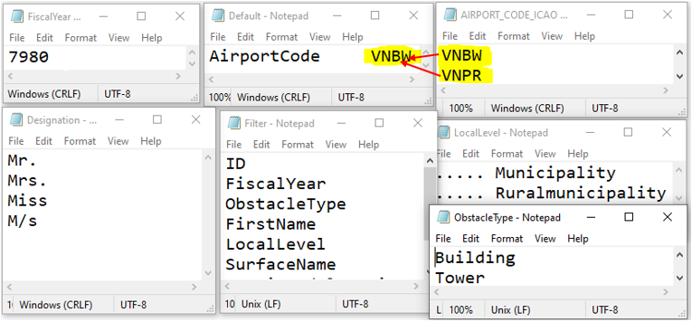

Figure 15. Other textfile content format

1. FiscalYear.txt
   1. Contains fiscal year data in column-wise list format
2. Default.txt
   1. Contains only one airport code among the codes specified in “AIRPORT_CODE_ICAO.txt”, which will be automatically loaded when the software opens by default. This can be changed to VNPR or VNKT or any other name among the list contained in “AIRPORT_CODE_ICAO.txt”
3. “AIRPORT_CODE_ICAO.txt”
   1. contains column-wise list of ICAO airport codes.
   2. However, IATA codes can also be used but all the files and folders should be renamed accordingly
4. Designation.txt
   1. Contains designation that will be put before name of the person/building/tower, etc. whose data is entered
5. Filter.txt
   1. Contains the column name of table shown in Figure 16, which can be used to filter the record in the table
6. LocalLevel.txt
   1. Contains local level name in English and must match the order contained in LocalLevelNepali.txt
   2. These texts are loaded in the combo box as shown in Figure 20 (for English) and Figure 21 (For Nepali/Devanagari)
   3. Selecting any name from “LocalLevel.txt” will automatically load corresponding name from “LocalLevelNepali.txt”.
7. ObstacleType.txt
   1. Contains the type of obstacle name in column-wise list format

## Content of Tab

### Load All Record

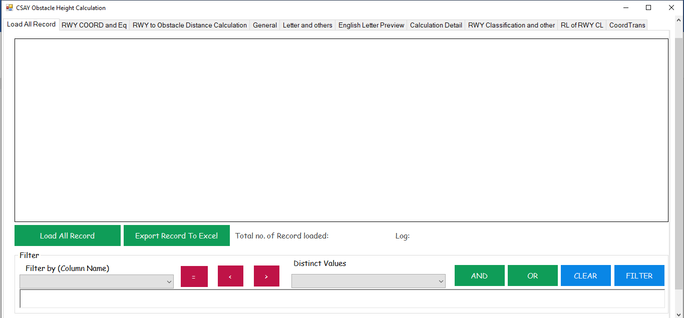

Figure 16. Load all Records Tab

### RWY COORD and Eq

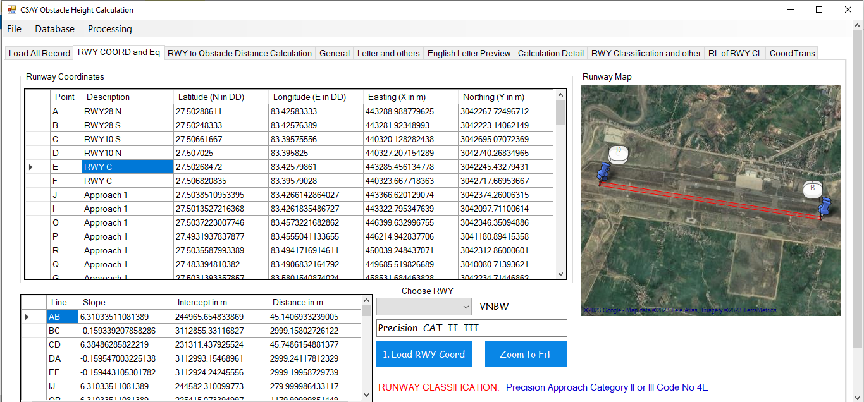

Figure 17. RWY COORD and Eq Tab

1. As in Figure 17, First enter the required data in specified format in text files as in Figure 12
2. Choose RWY
3. A Folder of the same name (Here, it is VNBW) should be present in folder and a file named “VNBW.txt” will be in the folder VNBW as shown in Figure 12 and Figure 14
4. Click button “1. Load RWY Coord” to load and “Zoom to Fit” to fit.
5. As in Figure 12, the “default.txt” contains name of the Airport code which will be automatically loaded, if file exists, when the software opens.
6. Runway Classification name will be loaded from “Precision_CAT_II_III.txt” as shown in Figure 12 and Figure 14.

### RWY to Obstacle Distance Calculate

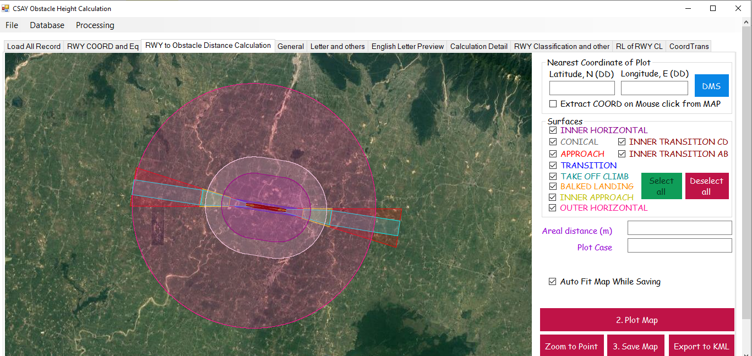

Figure 18. RWY to Obstacle Distance Calculate Tab

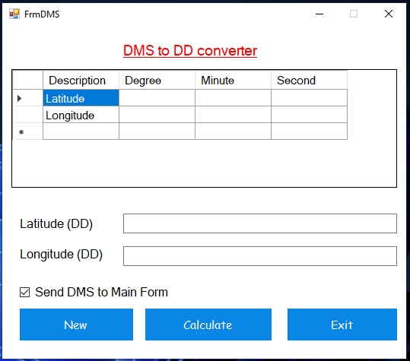

Figure 19. DMS to DD Converter

1. Input latitude and longitude in DD format.
2. Click DMS and enter latitude and longitude in DMS format as in Figure 19.
3. If “Extract COORD on mouse click from Map” is checked on, latitude and longitude text boxes will be filled the latitude and longitude of the map and if checked off, user has to input the coordinate themselves.
4. Under surfaces, select the required surfaces to display
5. Click button “2. Plot Map” to plot the obstacle and runway point and calculate areal distance
6. If “Auto Fit Map While Saving” is checked on, the map will be autofit to the points plotted and that map will be saved but if it is checked off, the user can adjust the map to desired zoom level by scrolling mouse wheel and then click “3. Save Map”
7. Click “Export to KML” to export the points of runway, obstacle and line joining them to KML file
8. “Zoom to Point” zooms map to the plotted point

### General

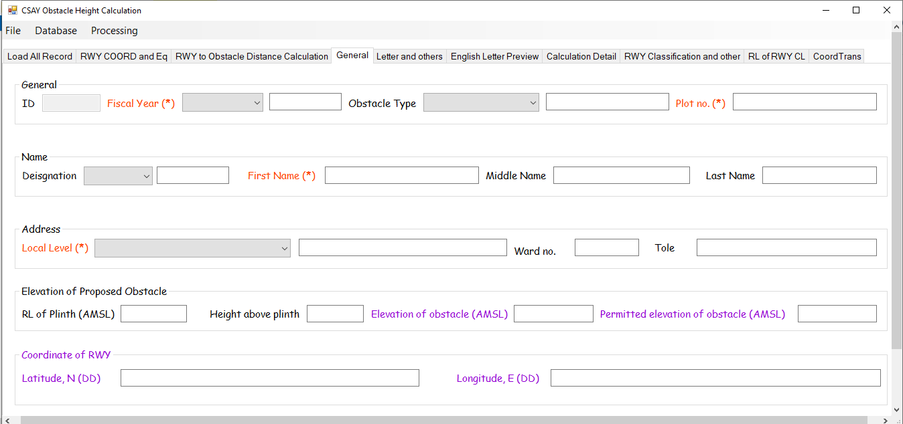

Figure 20. General Tab

1. All orange label marked with (*) are mandatory fields/textboxes
2. All black labelled fields are to be entered by user
3. Other are calculated or loaded from text files

### Letters and others

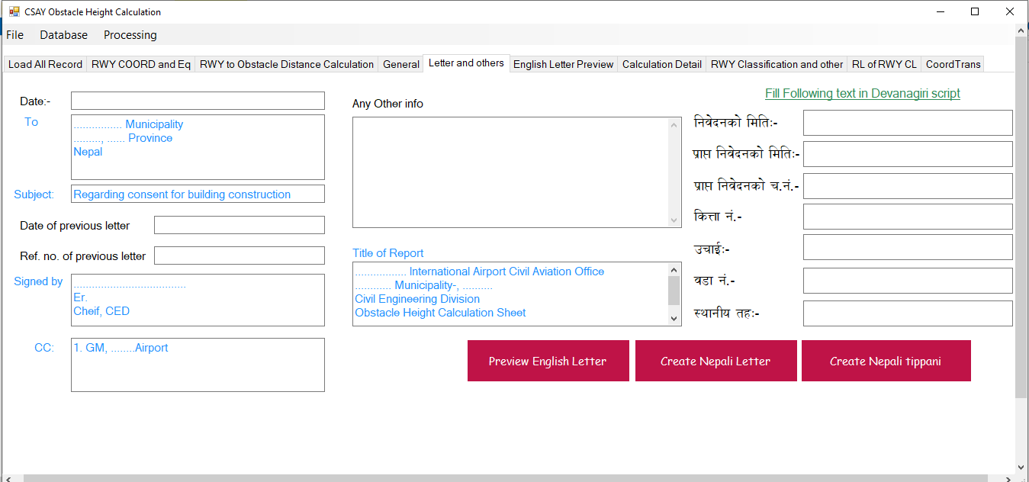

Figure 21. Letters and Others Tab

1. All black labeled are input
2. Blue colored fields are loaded form text files as shown in Figure 12.
3. No need to write in Devanagari i.e., Nepali because when you input in English, these Devanagari fields will be automatically filled
4. “Preview English Letter” button will open “English Letter Preview” Tab as shown in Figure 22.
5. “Create Nepali Letter” and “Create Nepali Tippani” button will create letter and Tippani in the format contained in “FormatFiles” folder as shown in Figure 12.

### English Letter Preview

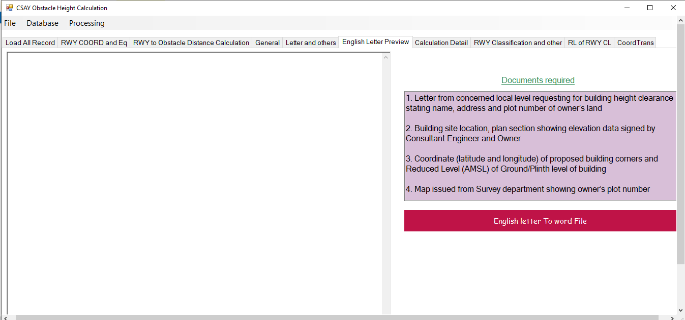

Figure 22. English Letter Preview Tab

1. English letter will appear in the white text box on the left-hand side
2. Date, designation, obstacle elevation etc. will be automatically filled after calculation and you have input all the required data
3. “English letter To Word File” will export the content of the text box in word file so that you can edit if necessary

### Calculation Detail

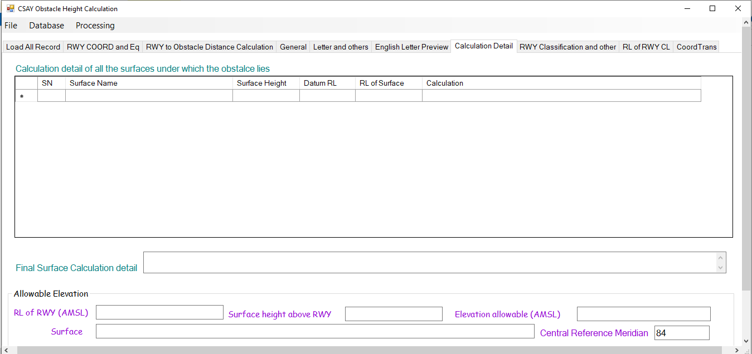

Figure 23. Calculation Detail

1. All the OLS below which the obstacle lies, will be listed with detailed calculation in the table as shown in Figure 23.
2. The minimum elevation data and corresponding surfaces will be shown in the text boxes and that shall be added to the table as shown in Figure 23.

### RWY Classification and other

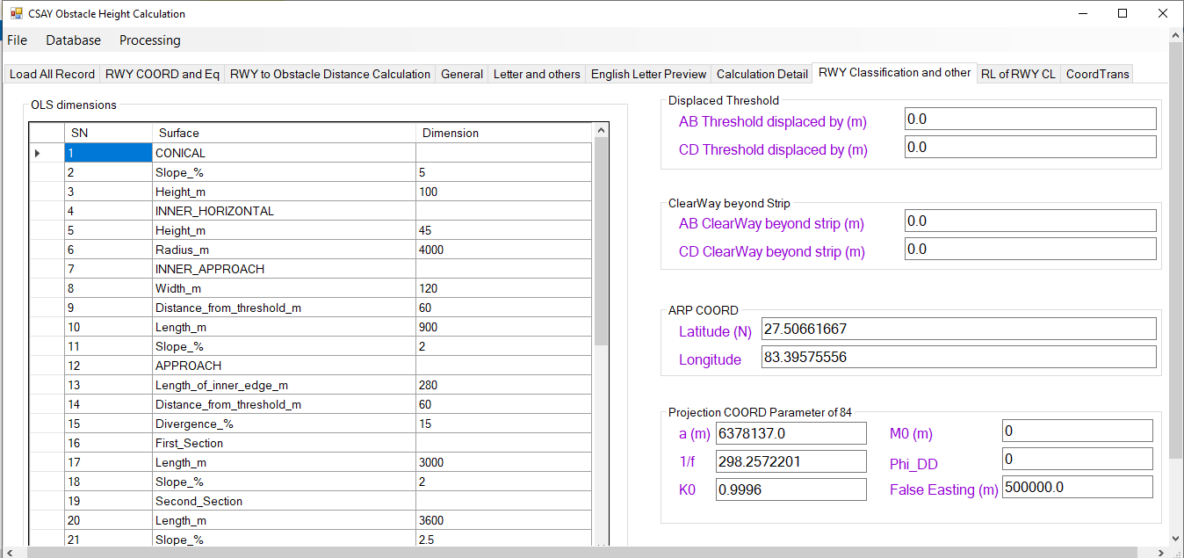

Figure 24. RWY Classification and other Tab

### RL of RWY CL

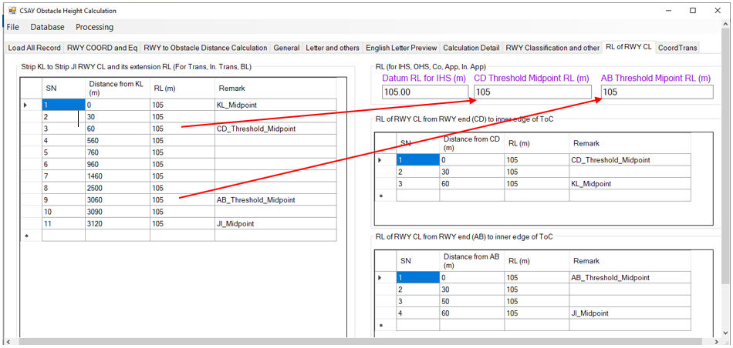

Figure 25. RL of RWY CL tab

1. After the user prepare input files as shown from 3.5 to 3.5.3, the tables and textboxes shown in Figure 25 will be automatically loaded.

### Coord Trans

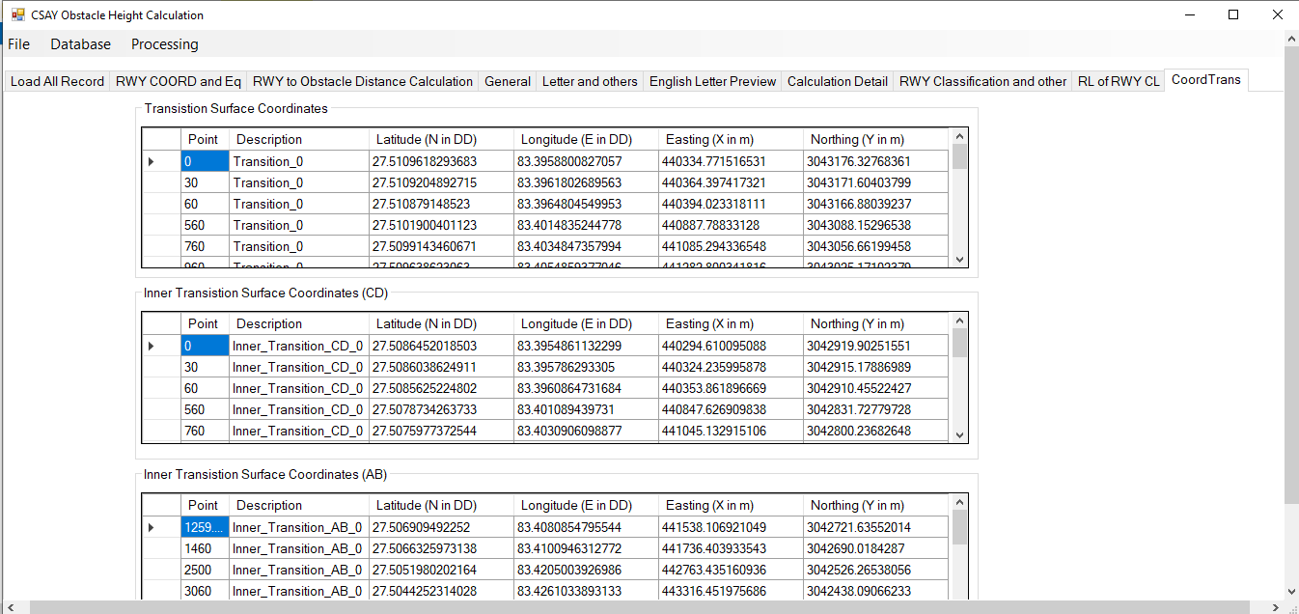

Figure 26. Coord Trans tab

1. The tables in this tab are automatically calculated after the user prepare input files as shown from 3.5 to 3.5.3

### Menu

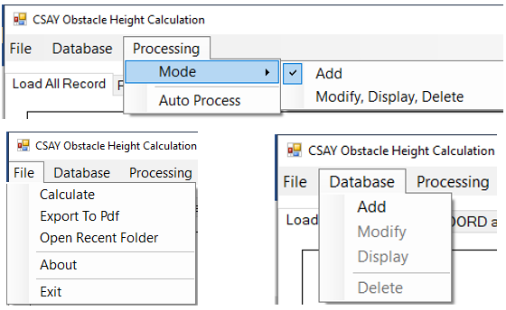

Figure 27. Menu

1. File menu
   1. Calculate
      1. After the user prepare input files as shown from 3.5 to 3.5.3, the use should click on “2. Plot map” of Figure 18
      2. Then users need to input “RL of plinth (AMSL)” and “Height above plinth” as in Figure 20
      3. Then user can click on File>Calculate and view calculation details as shown in Figure 23.
   2. After calculation and input of all black labelled fields, use can export report and English letter to pdf by clicking File>Export to Pdf
   3. “Open Recent Folder” Opens recently calculated and saved files
   4. “About” open about form as in Figure 28.
   5. “Exit” closes the software
2. Database menu
   1. “Add” to add data to database and ID auto-increases and All the projects are saved in Folder “ObstacleProjectFolders” as shown in Figure 12.
   2. “Modify” to modify the existing data
   3. “Display” to display the data after input of ID in General tab as in Figure 20
   4. “Delete” to delete the existing data
3. Processing
   1. Mode>Add
      1. When this mode is checked, Database>Add will be enabled, Project ID text field will be disabled in General tab as shown in Figure 20 and user will be allowed to add data
   2. Mode>Modify, Display, Delete
      1. When “Modify, Display, Delete” is checked on, “Delete”, “Modify” and “Display” of Database menu will be enabled and File>Add will be disabled and Project ID of General tab (Figure 20) will be enabled for user to input ID to display, delete or modify record.
      2. The ID can be known by clicking on button “Load All Record” of Figure 16
   3. Auto Process
      1. Firstly, prepare input files from 3.5 to 3.5.3
      2. Choose required airport code and click on “1. Load RWY COORD” as shown in Figure 17.
      3. Input coordinates in latitude and longitude format in respective fields as shown in Figure 18. RWY to Obstacle Distance Calculate Tab.
      4. Input all other required fields of General tab (Figure 20) and letter and others tab (Figure 21)
      5. Click on Processing>Auto Process and wait unit 100% processing is complete to generate reports, letters, Tippani, calculate obstacle elevation, export KML and save map.

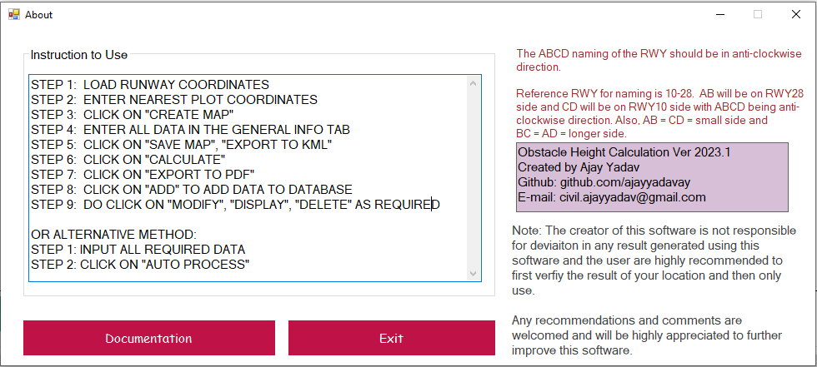

Figure 28. About

### Filter



Figure 29. Filter

1. Format of Filter is –
   1. ‘FirstName’=’Alpha’ OR ‘ObstacleType’=’Building’
   2. Those records will be shown in the table of Figure 16 having First name as ‘Alpha’ or Obstacle type as ‘Building’
   3. The user can use different such combination of filter
   4. Button “Clear” will clear the filter text field
   5. Button “=”, “<”, “>”, “AND”, “OR” have will input these texts in filter field
   6. When the user selects the “Filter by (Column Name)” loaded from “Filter.txt” (Figure 15), combo box “Distinct Values” will be automatically loaded.
   7. Distinct values of any column are the distinct values saved in the database under the same column of table Figure 16.

## Nomenclature of Runway corners

1. The naming of corners of Runway corners shall be according to Figure 30.
2. Reference runway is RWY 10-28
3. Non-reference runway is any runway other than the reference runway i.e., RWY 10-28
4. To name any non-reference runway (i.e., runway other than RWY 10-28),
   1. Draw the centerline runway edge strip rectangular line of reference and the non-reference runway
   2. Rotate the reference runway i.e., RWY 10-28 about mid-point of centerline of RWY in such a that all the following conditions are satisfied-
      1. AB should always be below the EW line
      2. CD should always be above the EW line
      3. ABCD should be in anti-clockwise direction
      4. AB and CD should be shorter sides i.e., along width of RWY
      5. AD and BC should be longer sides i.e., along the length of RWY
   3. Then get the latitude and longitude of corners A, B, C and D from google earth, GPS, etc. and write those coordinates Airport code text file (e.g., VNBW.txt, VNKT.txt, VNPK.txt, etc.) in the format specified as in **Error! Reference source not found.**.

*Note:*

1. *If the naming order is wrong or not as per specified, OLS cannot be drawn correctly.*
2. *Since the software code was written with respect to RWY 10-28 and parameters were then set for other runways so, RWY 10-28 is regarded as reference runway.*

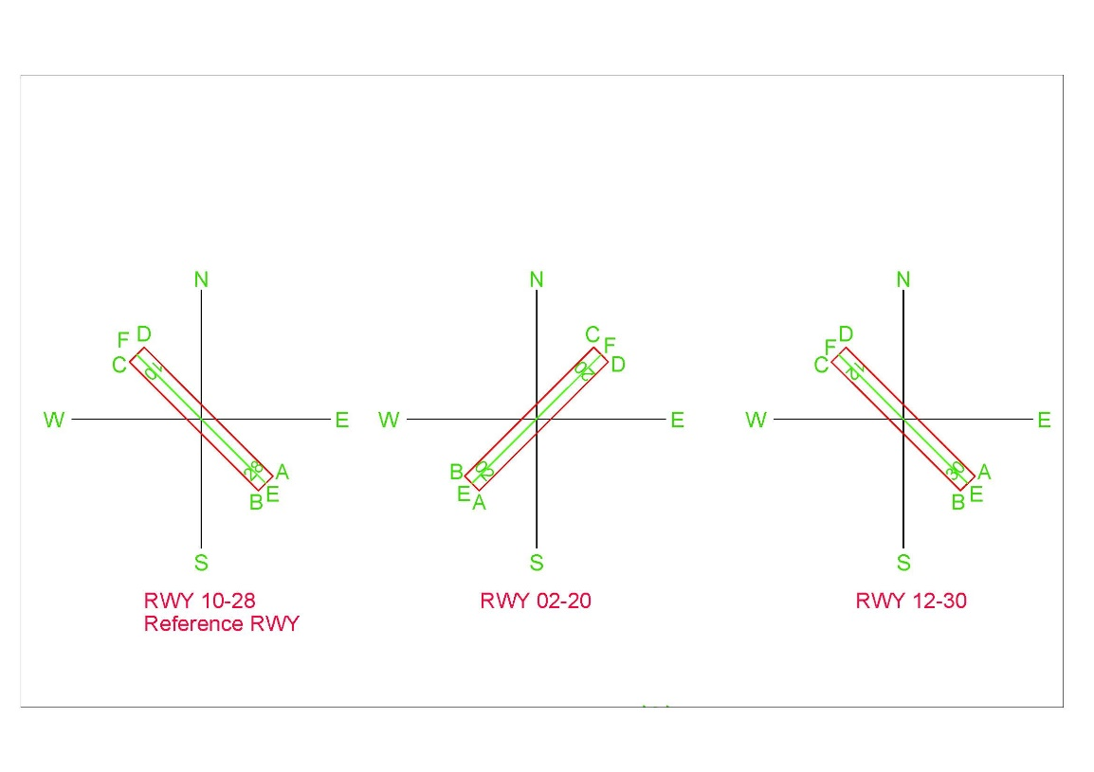

Figure 30. Runway corner nomenclature

## Output

### Report

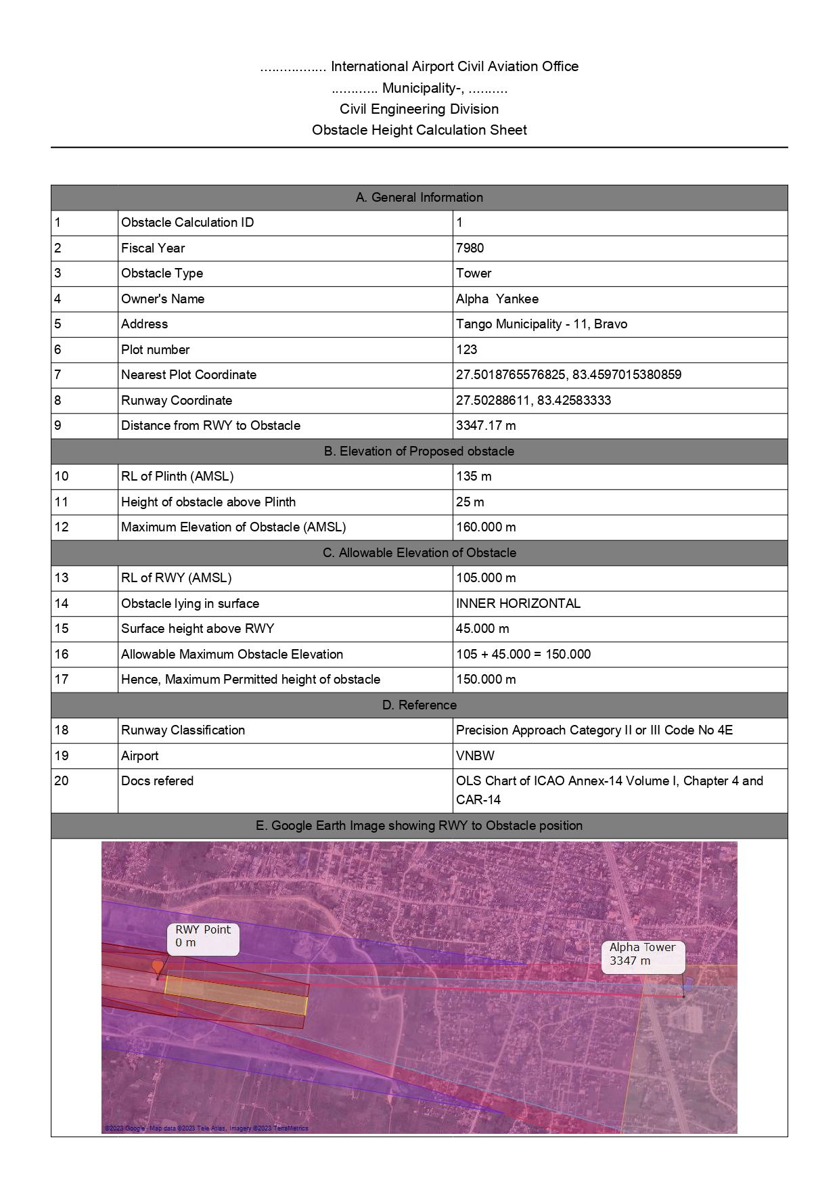

### Letter in Nepali

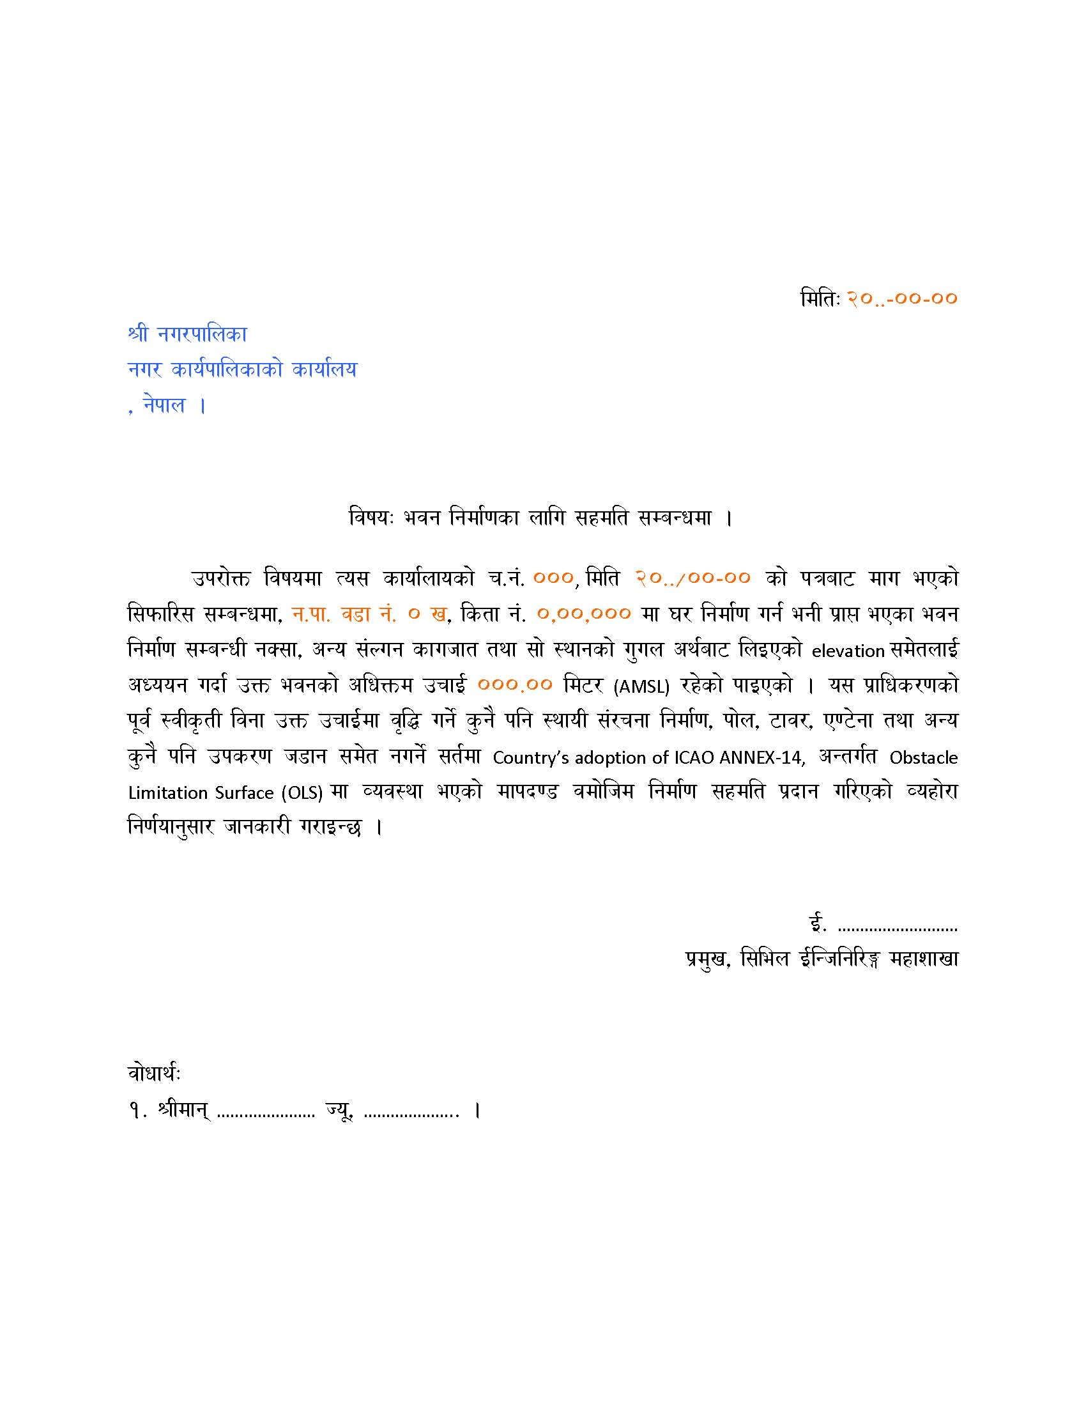

1. Note: In InputFolder>FormatFiles>LetterHeight_Template.dotx as shown above, the orange colored text is not be deleted or edited as they are bookmarked and software replaces these orange colored text with the calculated and user-input data.
2. However, the black texts can be edited as required and saved with same file name.

### Tippani in Nepali

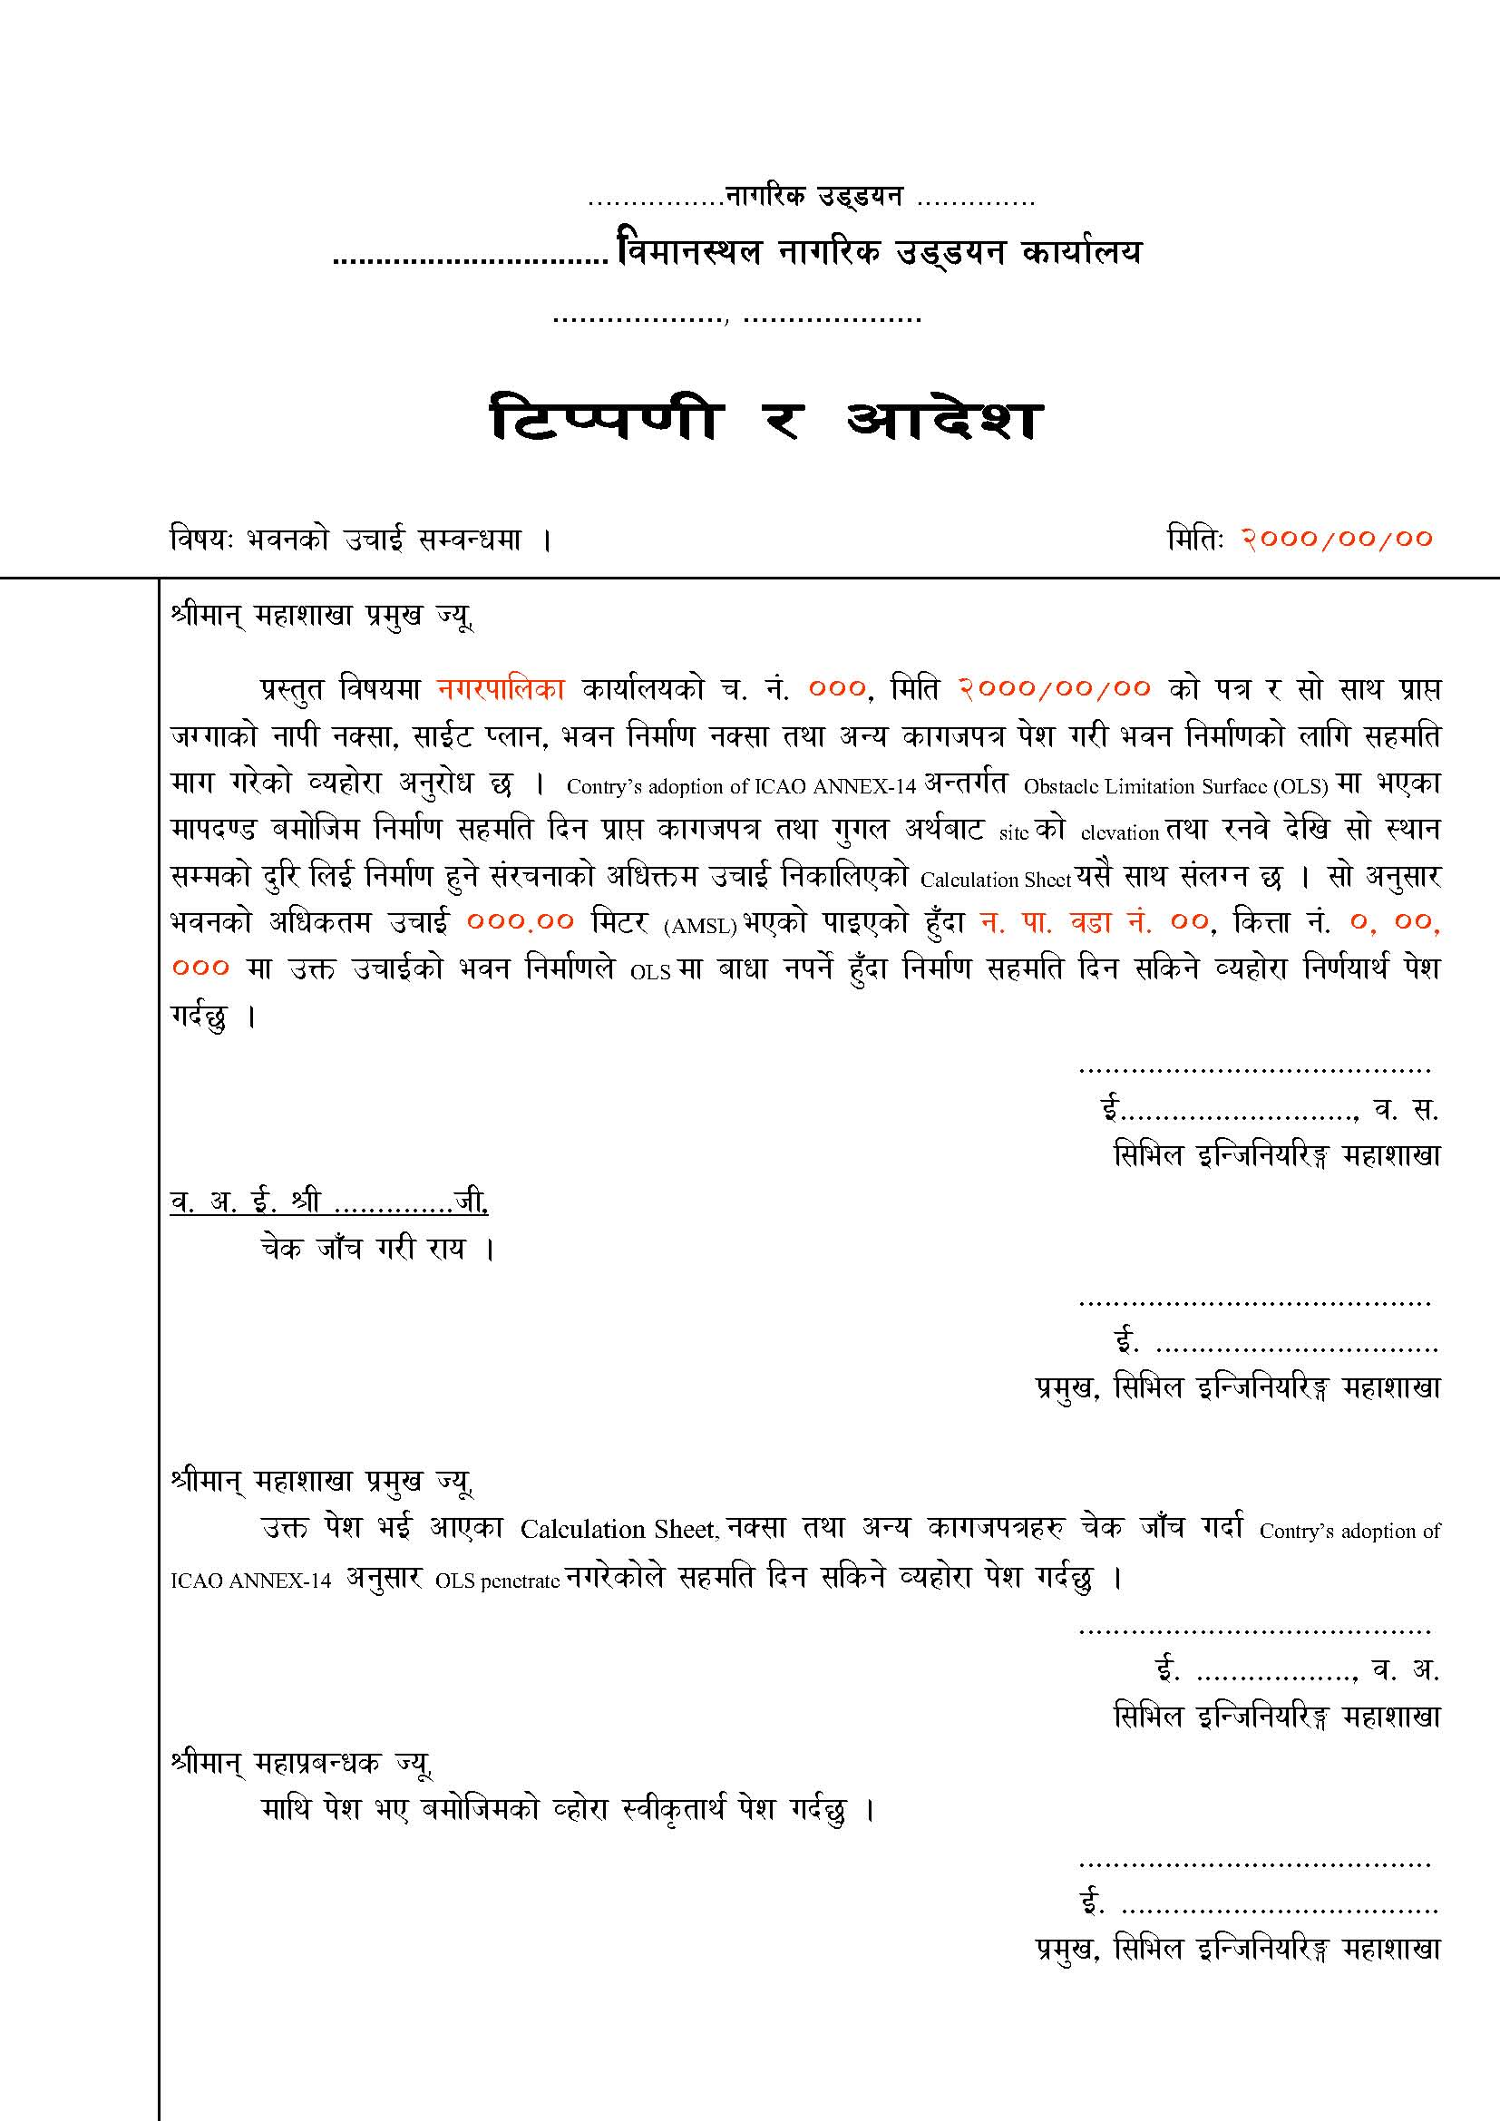

1. Note: In InputFolder>FormatFiles>LetterHeight_Template as shown above, the orange colored text is not be deleted or edited as they are bookmarked and software replaces these orange colored text with the calculated and user-input data.
2. However, the black texts can be edited as required and saved with same file name.

### Letter in English

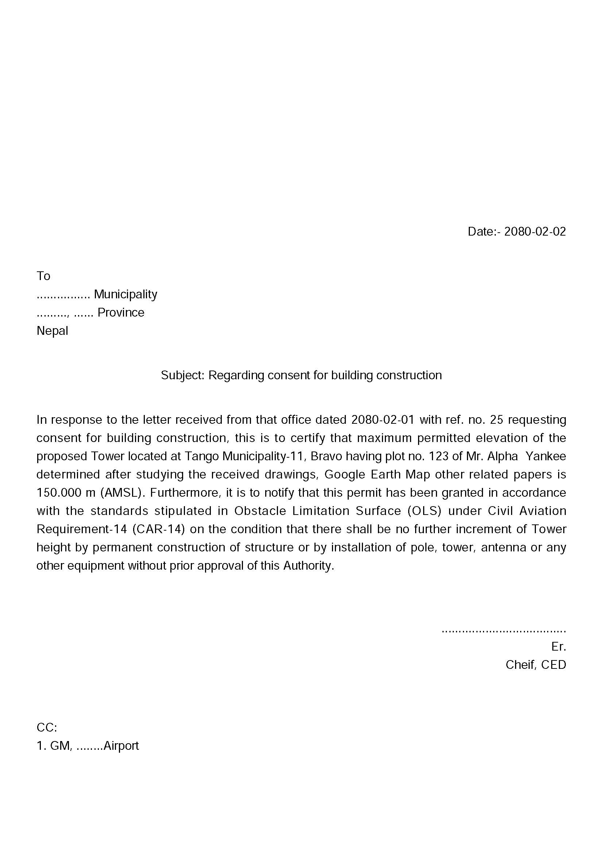

## Steps to calculate Obstacle Height with Auot-Process

The following steps shall be followed to calculate Obstacle height

1. Prepare input in all the text files as in Figure 12
2. Open the application

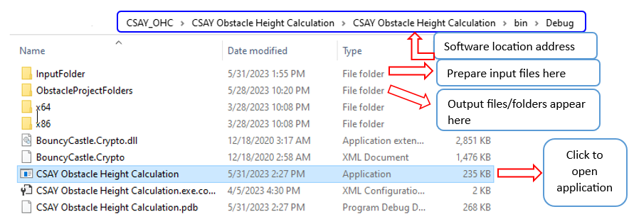

Figure 31. Software Executable file Location

1. The screen as in Figure 16 appears
2. Load RWY location data as in Figure 17
3. Navigate through different tabs and input all the fields labelled black in color as in Figure 18 to Figure 21.
4. Click “Auto process” from menu Processing>Auto Process Figure 27
5. The output will be saved in “ObstacleProjectFolders” as shown in Figure 31.
6. All records are stored in “ObstacleHeightRecord.sqlite3” located in the same as the application itself.